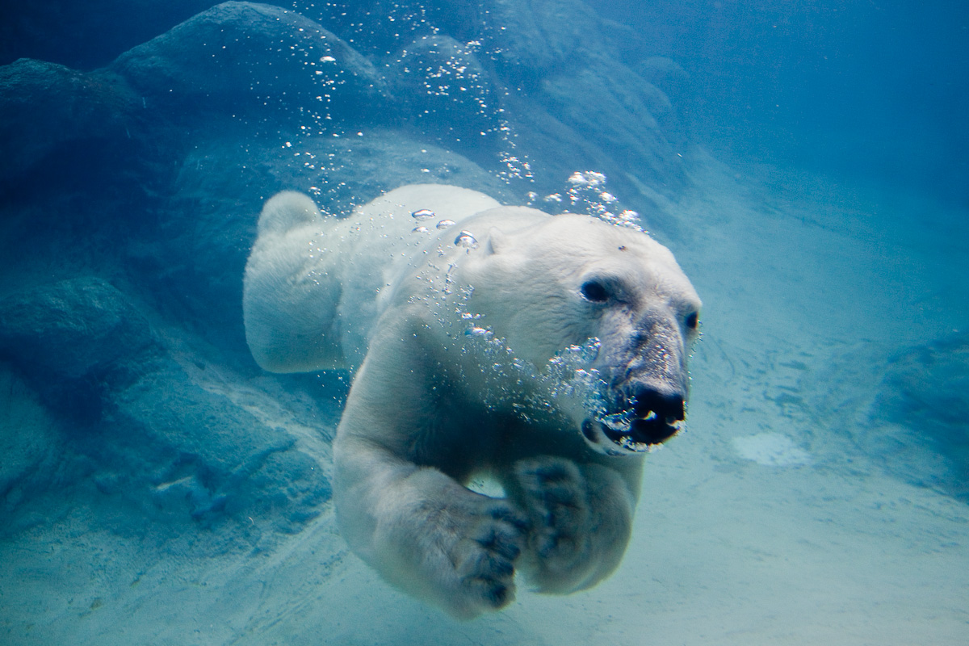
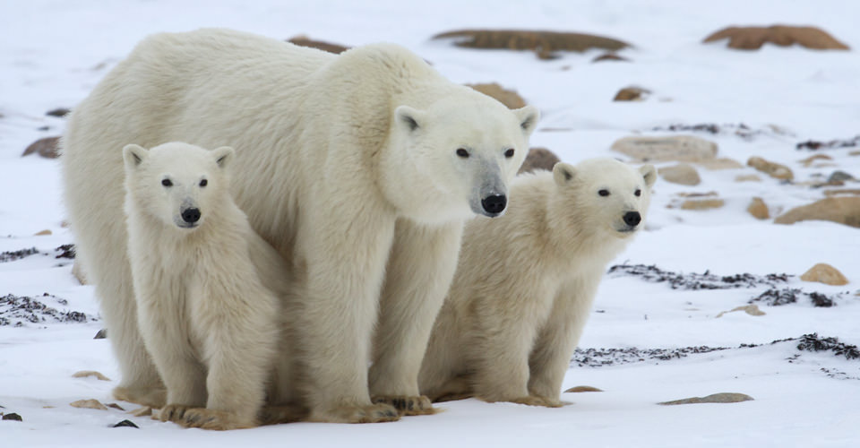
Polar Bears : A Summer Odyssey

Watch the video, ‘Polar Bears a Summer Odyssey’. The video will be shown in class, but it is also available here.

Part A

As you watch the video, consider three things (you may work with a partner).

Observation, Opinion, Question

1. State an observation from the video; something that ‘stuck’ with you.

2. State an opinion from the video; your ‘thoughts or feelings’ about something you saw.

3. State a question you have after viewing the video (it cannot be answered by the video).

4. Share your observation, opinion and question with the rest of the class on Edmodo

Part B

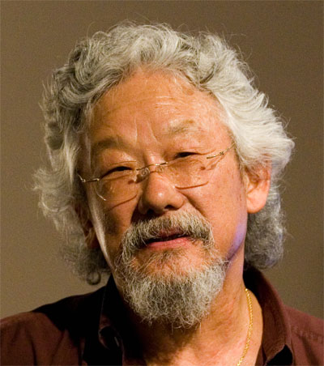
A very well known Canadian scientist narrated the video by the name of David Suzuki. Google David Suzuki and prepare a brief biography that follows the following criteria (you may use the medium of your choice).

Each slide should have a title, image(s) and colour. Use your space wisely.

1. Date and place of birth

2. Education (after high school)

3. Occupations / Jobs

4. Other than polar bears, state an environmental issue that David Suzuki obviously cares about.

5. Provide a hyperlink to a website / video that supports your answer to question #4

6. A question you would ask David Suzuki (if you could).

7. Upload (and be ready to share) your presentation to Edmodo.

