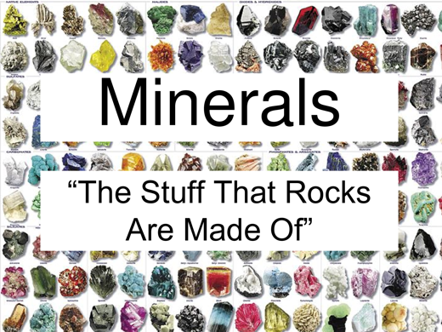
Minerals, Minerals, Minerals!

There are over 3000 known minerals! Some minerals are very common while others are very rare. Your task is to pick one of these minerals and create a brief presentation on that mineral. You may work on your own or with a partner. Keynote or Power Point would be good platforms.

Google different examples of minerals and pick one that interests you. However, before you begin, make sure you inform Mr. Sutherland of your choice. No two students or groups may repeat a mineral.

You will be sharing your presentation with both Mr. Sutherland and the class.

Your presentation will consist of 10 slides. Each slide will have a title. Each slide will have both images / diagrams and text (words / sentences).

- Title slide.

- Image Slide. Provide multiple pictures of the mineral.

- Physical characteristics slide (appearance).

- ‘Moh’s Scale of Hardness’ slide (image of the scale at least 5 different minerals scored on the Scale…but NOT your mineral). For each mineral scored, include an image of that mineral.

- Hardness Slide. How hard or soft is your mineral (its score on Moh’s Scale).

- Cleavage / Fracture Slide. When broken, how does it break up or split apart?

- Locations Slide. Provide examples of countries, provinces, states or regions where large amounts are found. Include a map(s). Include amounts mined. For instance, “In 2012, Nova Scotia produced over 55 tons of…”

- Uses Slide. Provide multiple specific examples of how the mineral is used.

- Value Slide. How valuable is the mineral?

- Trivia Slide. Provide an interesting piece of trivia or ‘Fun Fact’ about your mineral.

