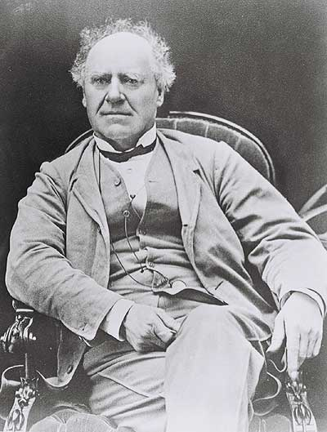
Joseph Howe : Reform in Another Time and Place
Mr. Sutherland, your desk needs reform!

Back To The Future?

Your task will be to move Joseph Howe through space and time and place him where reform is needed. Remember, reform means to change something for the better.

Find an image of Joseph Howe (picture or drawing). ‘Cut’ the image out (use a stylus to be exact) and superimpose it on another image where reform is required (remember the complaints survey we did). In other words, move Joseph Howe through space and time!

Then, use some type of text (speech bubble?) that outlines how Joseph Howe’s new location needs reform. (Remember the complaints survey we did?)

Your picture can be serious or humorous, but it needs to show that somewhere, somehow…reform is required.

Once your creation is complete, upload it to Edmodo and be prepared to share it with the class.

