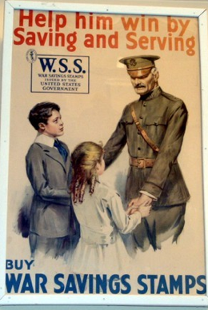
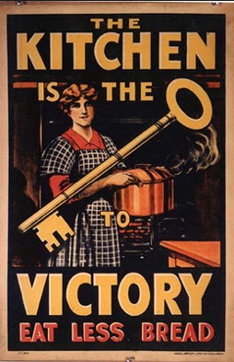
Life On The Home Front: Community Poster

Create a poster that could be publicly displayed in any city, town or community across Canada during World War One. The underlying message of the poster will be to encourage citizens to ‘do their part’ to support the war effort.

Your poster should make reference to factual specific strategies, efforts, events and techniques that have been studied. Recall there are examples found within chapter #16 of your textbook (please don’t duplicate the examples from the textbook).

Your poster needs to include elements of both images and text. You’ll also be graded on design, layout and use of colour. You may use a design platform of your choosing, but postermywall.com would be a possible choice. The attached will guide you as you create your poster. Of course, you also have the option of completing the poster by hand.

Here are a few videos to refresh your memory.

1. Victory Bonds
2. Rationing
3. Victory Gardens

 | 1-3 | 4-6 | 5-7 | 8-10
Use of  Colour To  Move Viewer | Satisfactory  Use Of  Colour | Good  Use Of  Colour | Great  Use Of  Colour | Excellent  Use Of  Colour
Layout and  Design As  A Venue To  Move Viewer  (Clear Message) | Satisfactory use of text, images, space and platform abilities | Good use of text, images, space and platform abilities | Great use of text, images, space and platform abilities | Excellent use of text, images, space and platform abilities
Connection to  Factual Activity or Strategy  (Real Events) | Poor explanation and connection | Satisfactory explanation and connection | Good explanation and connection | Excellent explanation and connection
Grammar,  Spelling and  Punctuation | Poor (most slides need revision) | Satisfactory  (many slides need revision) | Good  (few slides need revision) | Excellent (almost no revision needed)
Overall Effort and Attention To Detail | Minimal effort evident | Satisfactory effort evident | Good  effort evident | Excellent effort evident

