# mage result for flames

Home Heating Survey

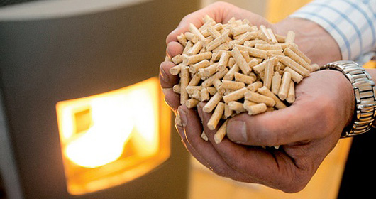

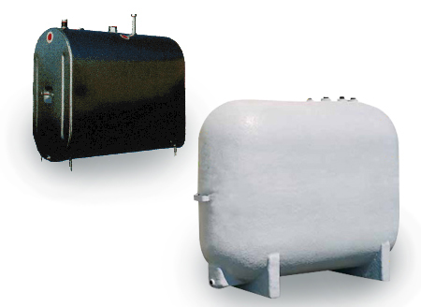1. What is the primary (**main**) source of heat in your home? Oil? Wood? Propane? Electric? What do you ‘burn’?

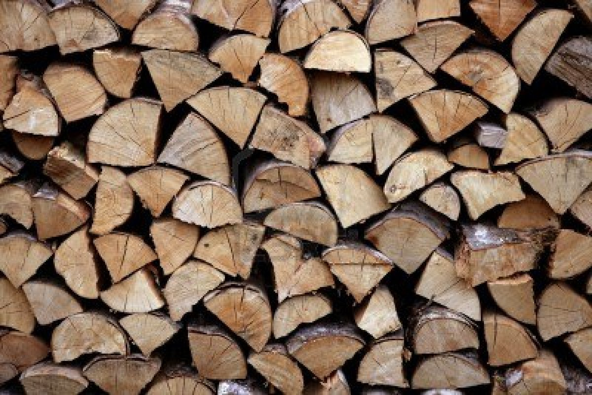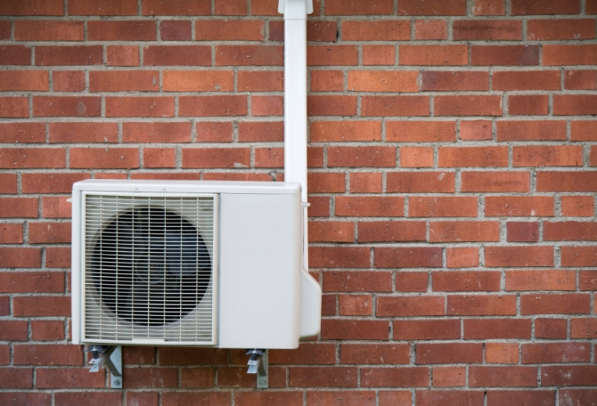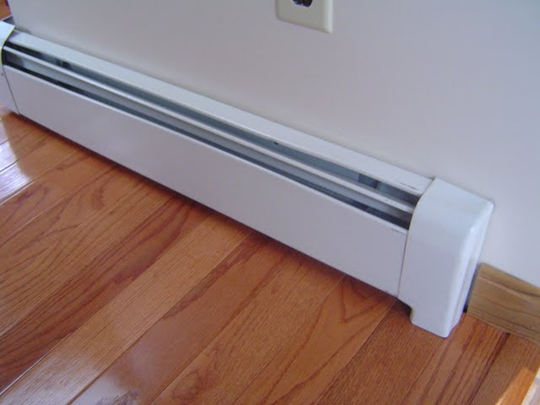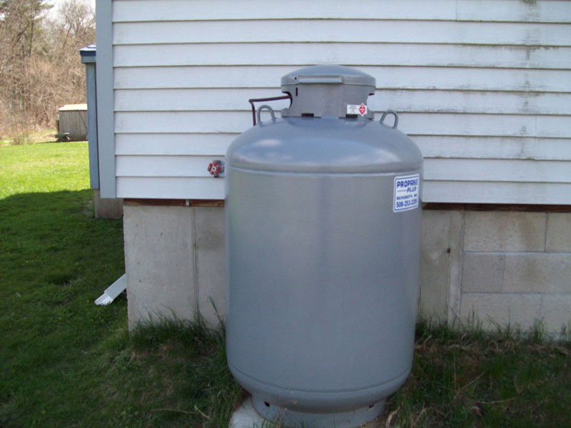

2. What (if any) are your secondary sources of heat? (**Record an answer even if you don’t use the secondary source**.)

3. What do YOU think will be the most popular choice for home heating (primary) in the class? Why?

4. Upload your response to Edmodo (Science folder). You may also submit a paper copy.

**A possible ‘good’ response…**

My main source of heat is a woodstove. I also have electric heat baseboard (which I rarely use). I also have an infrared heater (electric) that I use in the family room.

**A possible ‘bad’ response…**

My main source of heat is a furnace. *Although you stated a furnace, you haven’t stated what your furnace burns (wood, oil..*.)