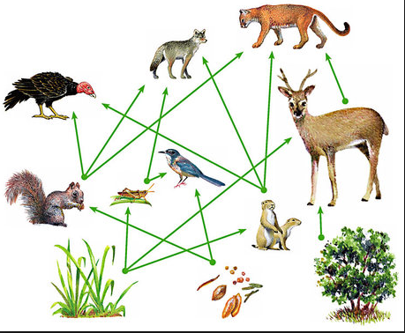
Food Web Assignment

This assignment may be completed with a partner or on your own. If you decide to work with a partner, please choose wisely. Standard rules for partners apply.

Design and create a themed food web that shows energy transfer within an ecosystem. Your food web must contain the following elements.

- An inclusive theme (Jungle, Harbour, Desert, Arctic, Forest, Prehistoric…)
- An obvious title connected to the theme ( ‘Barnyard Food Web’)
- 10 organisms if you work alone, 15 if you work with a partner
- At least two organisms must be producers
- All organisms will include two labels. The first label will be what the organism is (Rainbow Trout) The second label will be either producer or consumer
- You may use a key for producer / consumer. Then, use ‘P’s and ‘C’s
- Three definitions in your own words (Food Web, Producer, Consumer)
- Organisms must be connected to other organisms with arrows showing energy flow (the arrow points in the direction of energy flow)
- You may print off a maximum of two organisms (four if with a partner) The rest of the organisms will be drawn free hand
- Google what your organisms eat or don’t eat (accuracy)
- For any and all text, don’t use pencil. Consider Sharpie markers, colour pencil, crayon or print off and attach your labels.

You will be graded on the following:

- Completeness (Have you done all tasks?)
- Labels (Are all present and accurate?)
- Design and layout (Use your space wisely)
- Colour (Use lots of colour. Your food web should ‘pop’ !
- Definition accuracy
- Effort
- Spelling and grammar (Peer editing is recommended)
- Energy flow arrow direction (Lettuce doesn’t eat rabbits)

You are not being graded on your ability to draw. That’s why everything will be labeled (in case I think your grizzly bear is a raccoon). I’m more interested in your
degree of effort, creativity and your level of understanding.

As a background, you may use poster board or Mr. Sutherland has LARGE sheets of white paper (just ask).

Organisms don’t have to be drawn to scale (Your lettuce can be larger than your rabbit).

