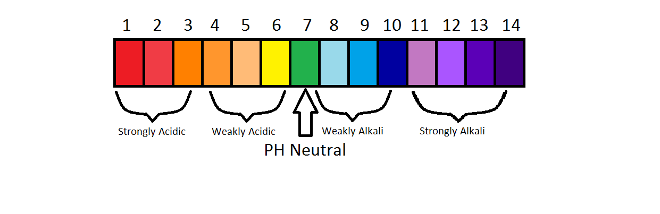
Designing a pH Scale

1. Pick 10 items and determine their value on the pH Scale.

2. Either digitally or ‘old school’ create a pH Scale and insert the 10 items you chose (to their correct placement).

3. Include a title.

4. Include a brief ‘blurb’ somewhere on your assignment that indicates what the pH scale is used for (1-3 sentences should be fine).

5. Each item placed on your scale must be labeled and scored (pH value).

6. Use lots of colour. Use your space wisely (don’t crowd your items). Neatness and effort!

