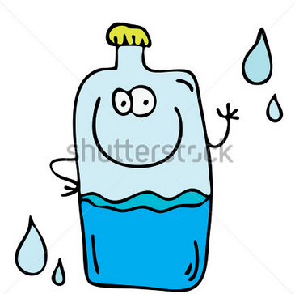
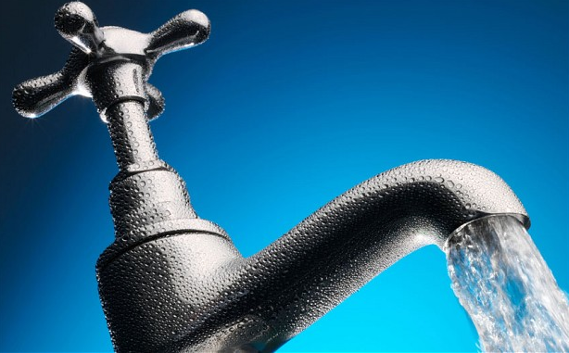
Water, Water, Water !
(Place answers on loose-leaf or upload a digital copy to Edmodo.)

1. What percentage of a human’s body is water?

2. How much of the earth’s surface is covered by water?

3. What percentage of the earth’s water is ‘salty’ (oceans, seas)?
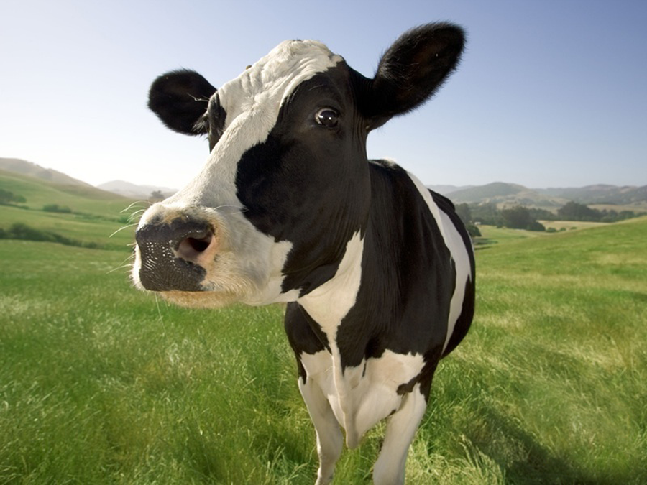
4. What country has the most fresh water?

5. What percentage of milk is water?

6. How much water does the average person drink in alifetime (in litres)?
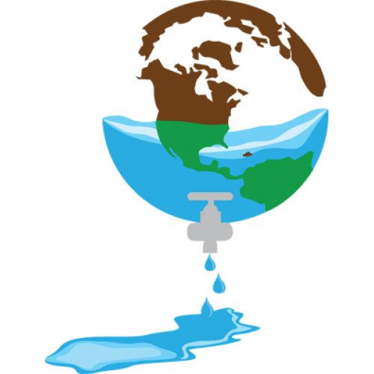
7. Which can people live longer without, water or food?

8. What percentage of the earth’s water is ‘drinkable’?

9. Within the average person’s home, which room sees the most water used?

10. What is the name for the medical condition caused by ‘drinking too much water’ (it can be fatal)?

11. How much water is in an Olympic sized swimming pool (in litres, not gallons)?
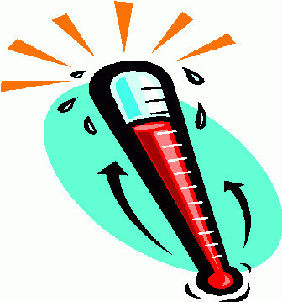
12. In Celsius, at what temperature does water boil (at sea level)?

13. What takes place at the Jebel Ali Plant in Dubai (in the Middle East)? Be specific.

Go to the following website and read the ‘28 Facts About Water’ 28 Water Facts

14. Which ‘fact’ did you find the most interesting? Be ready to share your fact.

15. What was one fact that you already knew? Be ready to share your fact.

