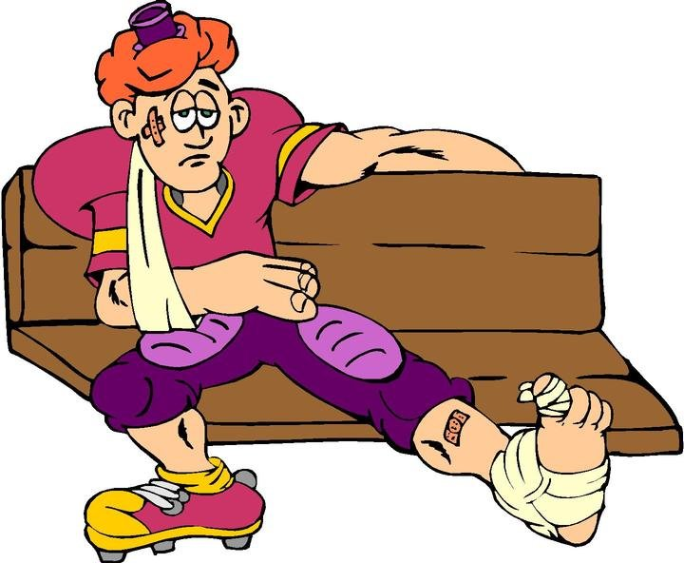
Sports Injuries

With a partner on your own, create a presentation that deals with a specific injury that is often associated with sports. As you create your slides, use this document to ‘check off’ each slide when it’s completed. Use Keynote, PowerPoint, iMovie or some other platform.

Your presentation will contain the following…

#1. _____ Title Slide. It will include the type of injury and the presenter(s) name(s).

Slides #2 and #3 may be combined.

#2. _____ Description Slide. A brief description of the injury. Include how serious it is (or can be).

#3. _____ Injury Incident. A brief description of how the injury occurs. Include sports or activities in which the injury is common.

#4. _____ A symptoms slide. What are symptoms of the injury?

#5. _____ Treatment slide. How is the injury treated? Include things such as medication, therapy, surgery or any other form of treatment.

#6. _____ Prevention slide. What are the best ways to prevent the injury?

#7 _____ Famous Person slide. An example of a well-known person who has been affected by this injury.

#8 _____ Fun Fact slide. A statistic, piece of trivia or ‘fun fact’ regarding the injury.

#9 _____ Hyperlink / You Tube slide. Create a link to a related website (other than Wikipedia). If it’s a You Tube video, it should be less than two minutes. If it’s a video, it must be cleared through the teacher before showing (some people are squeamish).

#10 _____ Reference Slide. List the references (web sites) you used. You should use at least three different resources.

Points To Remember.

All slides should have at least one image, diagram or chart. Slides should not be ‘text heavy’ (too many words). One to five sentences for each slide.

Don’t cut and paste phrases. Use your own words!

If you use BIG words, then know what they mean!

Transitions and animations are fine, but don’t let them be a distraction from your slides.

Use your space on each slide wisely (design and layout).

Slides Checklist: Use the following checklist when you ‘think’ your project is complete.

Sports Injury Powerpoint : Checklist
____ Title slide
____ Description of injury slide (what happens).
____ Sports associated with injury slide
____ Symptoms slide
____ Prevention slide
____ Treatment slide
____ Well-known athlete (person) slide
____ Statistic / trivia slide
____ Test questions slide
____ Bibliography (sources) slide

