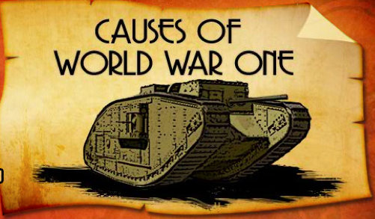
Representing the Causes of World War I

With a partner or in groups of two, choose one of the critical events that led up to the beginning of World War I.

Part 1: The Brainstorm

With your partner, brainstorm some of the key events that took place prior to World War I (events that contributed to the cause of the war). Record your brainstorm. Collaborate with two other groups to compare your results.

Part 2: Pick and Choose

Choose one of the events that you feel you could represent in a creative way

Part 3: Pick A Platform

Choose a method to represent your ‘cause’. IMovie, Explain Everything, Stop Motion…you decide. However, you must clear your platform of choice with the teacher. Share your presentation with the class.

Part 4: The Essentials

Your final product must include the following:

- A clear and obvious title
- Visible text or audio that clearly explains what’s taking place
- If it’s a ‘press and play’ event, it should be between 1-3 minutes (but this amount is open for discussion)
- Consider the 5 W’s (who, what, where, when and why)
- Be thorough, accurate and neat

Part 5: The Rubric

1. At the end of each work class, you will assess your own level of progress.

2. The final product will be assessed based on the following rubric.

Part 6: An Example

Here’s a good example from previous students completing the task. It was made using Stop Motion and iMovie. Click Here.

