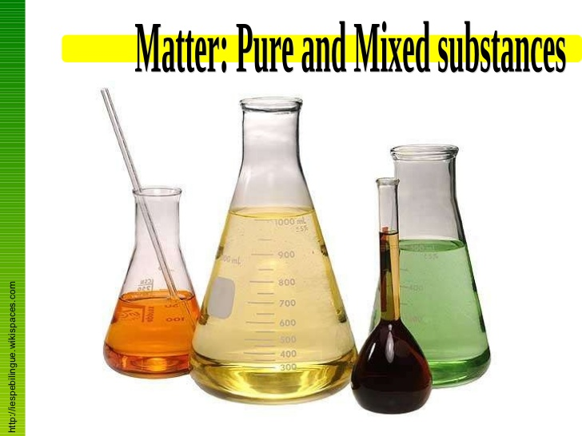
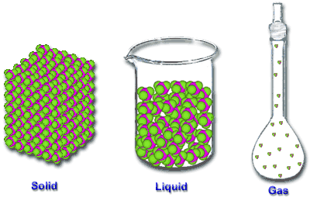
Representing Pure Substances and Mixtures

First of all, review the differences between the different types of mixtures and pure substances. A quick video review can be found here.

Using Pic Collage, create a visual that clearly shows (with both text and real world examples) the difference between homogeneous mixtures, heterogeneous mixtures and pure substances.

Your finished product will include a title and appropriate labels. You need to include at least one example of a solid, a liquid and a gas.

Use your space wisely. Spelling and grammar count. Be ready to share your finished product!

Check the rubric below before you submit!

 | 0-1 | 1-2 | 2-3 | 3-4
Appropriate  Title | Unsatisfactory | Satisfactory | Good | Excellent
Labels Present /  Accurate | Unsatisfactory | Satisfactory | Good | Excellent
Spelling  Grammar | Unsatisfactory | Satisfactory | Good | Excellent
Design  Layout, Use of  Space & Colour | Unsatisfactory | Satisfactory | Good | Excellent
Pure Substance, Homogeneous, Heterogeneous (All Present) | Unsatisfactory | Satisfactory | Good | Excellent
Solid, Liquid, Gas  (All Present) | Unsatisfactory | Satisfactory | Good | Excellent
Overall Level of Effort | Unsatisfactory | Satisfactory | Good | Excellent

