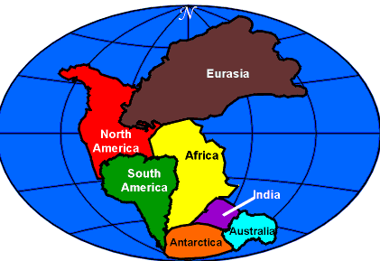
“Pangaea : A Digital, Drifting Continent Story”

The following task will be completed in small groups (2-3 people).

Driving Question: Show how the continents have moved over millions of years.

Your task is for your group to create a digital story of how the continents have moved over millions and millions of years. Using the Stop Motion app, create your production.

1. Given modeling clay of various colours, create shapes that resemble the world’s present day continents (try to use a different colour for each continent).

2. Create small labels for each continent.

3. Move the continents together for the ‘best fit’ (like a jigsaw puzzle). This will be your starting point.

4. Starting with your continents together, take at least 100 pictures of your continents ‘moving’. Include periodic ‘signs’ with your pictures that indicate how many years ago the continents were positioned the way they are (according to the picture you took). There definitely must be a starting sign ( ____?____ million years ago) and an ending sign (Present Day). There should be at least five signs in total. Keep in mind the last picture will look like the present day earth.

5. Your production must include some form of audio (whether voice over or sound). Remember, this is a digital story of how the continents moved to their present day location.

6. When you feel your production is complete, share it with at least two other groups in the class. Ask for suggestions or comments.

7. Finally, upload your completed production to Edmodo.

