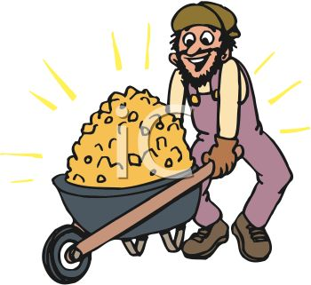
Mining Chocolate Chip Cookies!

You will be mining chocolate chip cookies to separate the chocolate chips from the batter. The chips will represent the mineral while the batter will represent the ore.

Materials: digital scale, chocolate chip cookies (3 possible brands from which to choose), loose-leaf and two skewer sticks.

Procedure:

** Note that for any weighing you will need to place your cookie (or its parts) on a loose-leaf place mat before you place it on the digital scale. **

1. Weigh the piece of loose-leaf you will be using as a ‘place mat’. This weight must be subtracted from any future weight totals you use.

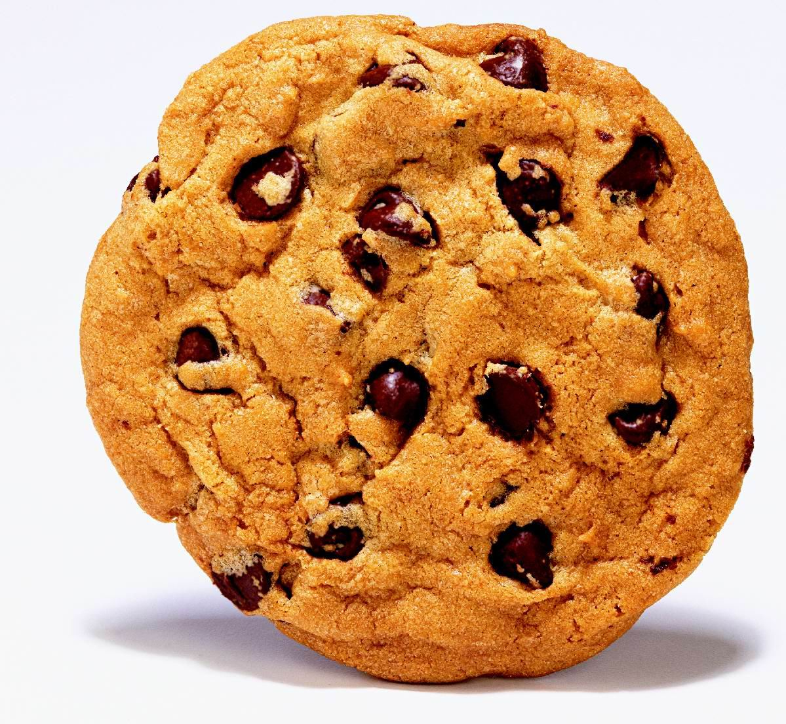
1. Record which scale and cookie type your have. It’s important to always use the same scale, as there might be slight differences between scales. Round to the nearest whole number. So, 5.8 grams would be 6 grams.

2. Weigh your cookie; record the weight.

3. By hand, break up your cookie into several small chunks.

4. Use the skewer sticks to further break apart your cookie. If you try to use your fingers, the chocolate (mineral) will melt! Congratulations, you’re mining!

5. Once you have two distinct piles of chips and batter (minerals and ore) ask a peer if your chips look like enough batter has been removed. Ask also the teacher. If you’re good to go, weigh and record each pile!

6. Eat your piles (or share with a friend).

Follow Up.

Once all the data has been collected for the class, determine which cookie has the highest grade ore.

