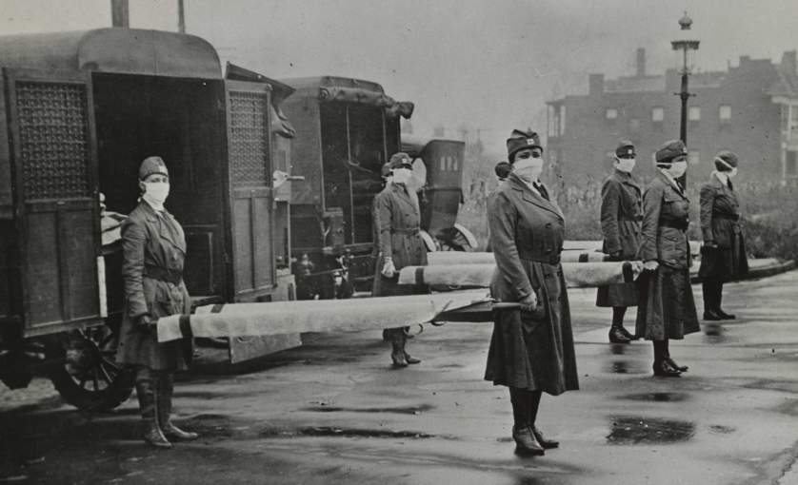
Microbes: The Spanish Flu Pandemic!

With a partner, view the 10 minute video at the following link. Then, complete the following.

Part A

1. Clearly state three things that you already knew after watching the video.

2. Clearly state three facts or statistics that you learned after watching the video.

3. Clearly state three relevant questions that come to mind after watching the video.

Part B

Now, find another You Tube video (preferably less than 5 minutes) that deals with an illness or condition that is caused by exposure to a microbe (bacteria, virus, protozoa, fungus). It can’t be a Spanish Flu video. Upload the link to Edmodo and share it with the class.

Your video choice must be cleared through the teacher (to avoid duplication with other students and to make sure it’s appropriate).

Part C

Finally, create and submit a pic collage with a title and at least five different images related to either the Spanish Flu, the other disease or condition you You-Tubed or microbes in general

 | 0-1 | 1-2 | 2-3 | 3-4
‘Already Knew’ | None | 1 | 2 | 3
‘Facts or Statistics’ | None | 1 | 2 | 3
‘Relevant Questions’ | None | 1 | 2 | 3
You Tube Video Find | Unsatisfactory | Satisfactory | Good | Excellent
Self Effort | Unsatisfactory | Satisfactory | Good | Excellent
Group (Partner) Effort | Unsatisfactory | Satisfactory | Good | Excellent
Pic Collage Task | Unsatisfactory | Satisfactory | Good | Excellent

