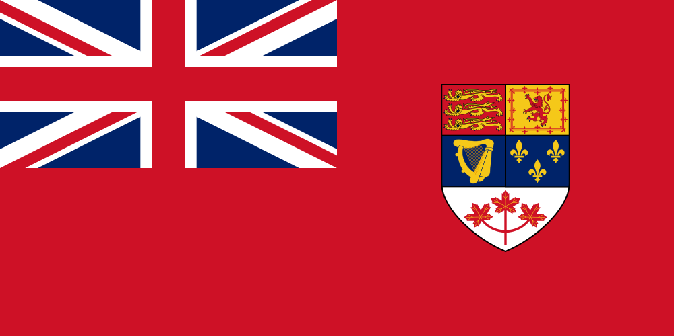
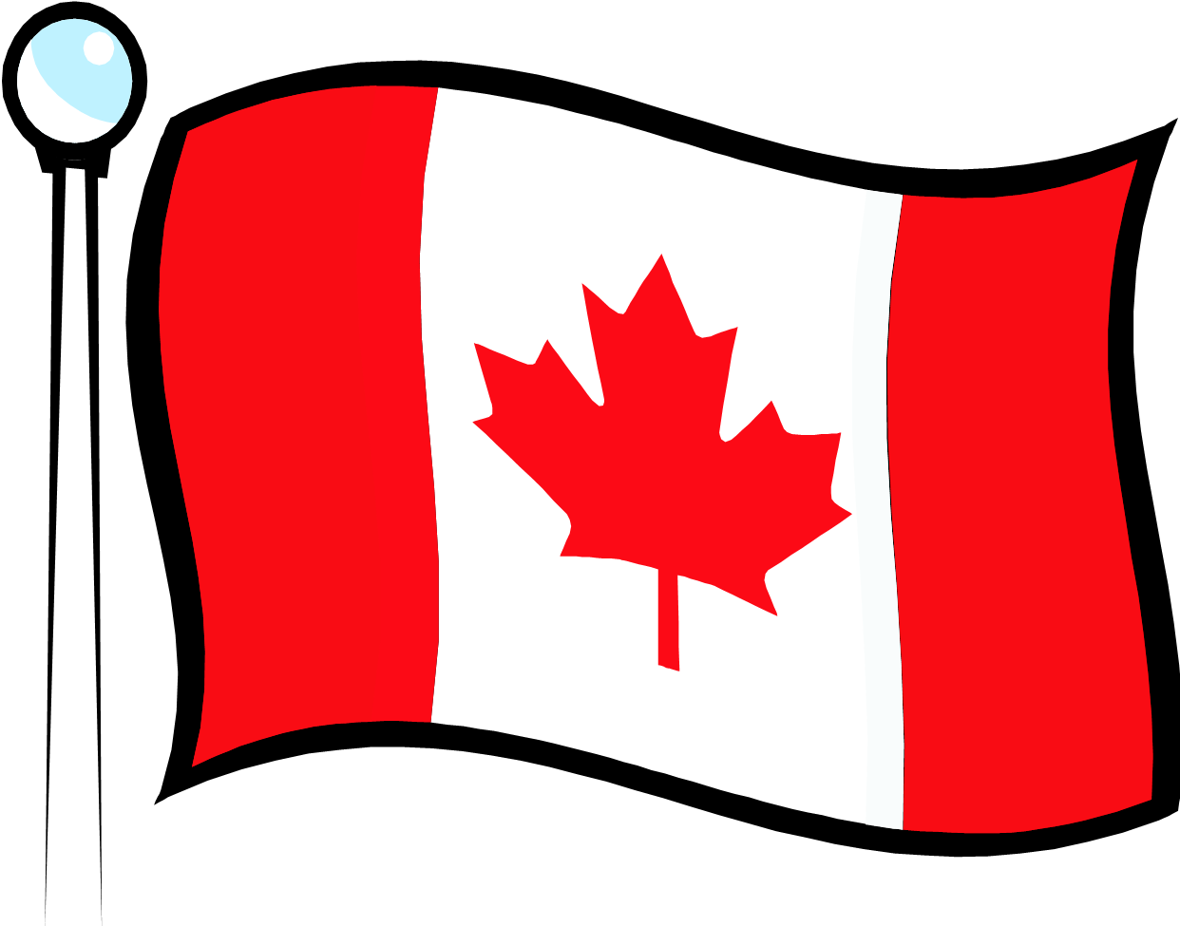
1957-1965
Flag Day (Feb. 15)
1965-present

Part A : Google the provincial and territorial flags of Canada. Which flag(s) has…

1. a bison 4. a ship 7. a Union Jack 10. bales of wheat
2. an inukshuk 5. a rising sun 8. a blue star
3. an oak tree 6. a flower 9. a husky

Part B :

Google, ' Proposed Flags For Canada'. (Or you can try the following site.)

Answer the following questions.

1. How many leaves were on the design proposed by Fortescue Duguid and John Matheson?

2. One flag proposed in 1963 featured a Canadian animal on the flag. Which animal?

3. Of the flags pictured, how many had a Union Jack?

4. How many flags showed a ‘fleur de lis’?

Part C :

Design your own version of a flag for Canada. Below your flag, explain the Canadian significance of the colours and symbols you chose.

Part D :

Periodically, the Royal Canadian Mint introduces a new coin with a new design (image).

1. Google the images that were placed on the following coins in 1967 (Canada’s 100th birthday). Which coin had which image (penny, nickel, dime and quarter)?

2. Imagine you were given the task of designing a new coin for Canada. Using the template below or a digital version, show how your coin would appear. Be ready to explain your choice and how you feel it represents Canada.

