Confederation Dates (And More)

With a partner, choose a Canadian province or territory and complete the following task. (You may be assigned a province or territory to limit duplication.)

Using either the Stop Motion or Explain Everything app, create a production that illustrates the following for your province or territory. (If you’d like to experiment with another medium, talk with Mr. Sutherland…we’ll see what we can do).
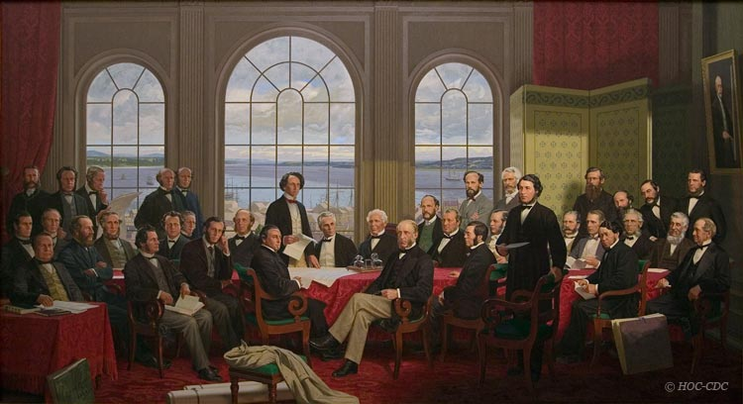
- The date it joined Confederation (joined Canada)
- Its current population (or at least from the last three years)

- Its capital city

- Its total land area (in square kilometres)

- Where it ranks in Canada (in terms of its size, not its population)
- Its flag

- Its coat of arms
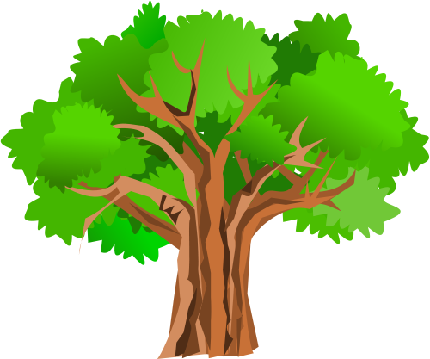
- Its flower

- Its tree

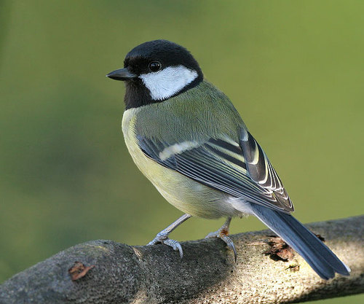
- Its bird

- Vehicle license plate

- An interesting piece of trivia or fact about your province / territory

Your presentation must include voice and text for each of the above points. Each of the above points must also be represented by an image in your presentation. Feel free to ‘jazz it up’!

Once your presentation is complete, upload it to Edmodo and be ready to share it with the class!

Rubric Below:

Appropriate  Title | Unsatisfactory | Satisfactory | Good | Excellent
Labels Present (for each component) | Unsatisfactory | Satisfactory | Good | Excellent
Spelling  Grammar | Unsatisfactory | Satisfactory | Good | Excellent
Design  Layout, Use of  Space & Colour | Unsatisfactory | Satisfactory | Good | Excellent
All 12 Components Present | Unsatisfactory | Satisfactory | Good | Excellent
Component  Accuracy (bird, tree, flower…) | Unsatisfactory | Satisfactory | Good | Excellent
Use of Voice or Text | Unsatisfactory | Satisfactory | Good | Excellent
Overall Level of Effort | Unsatisfactory | Satisfactory | Good | Excellent

