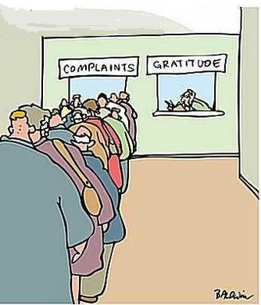
What Do We Complain About?
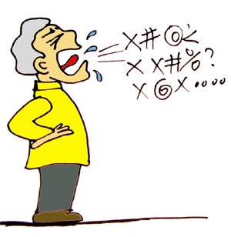

At home, interview an adult and ask them what they complain about. Record at least three different complaints. Ask them to list complaints that are, in theory, changeable. In other words, avoid topics such as the weather.

If they can’t think of three, ask them what they hear ‘other people’ complaining about.

Upload and record your complaints to be shared with the class.

